

PROJET INTEGRATEUR

Groupe 7

CHEMIN

DU

ROBOT

Légende :

* distances
* bâtiments

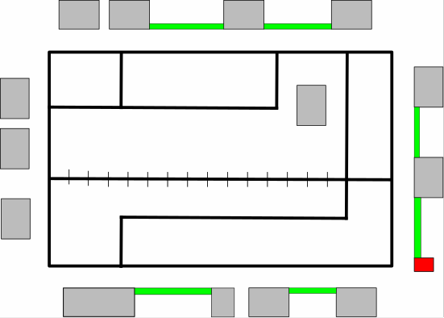

P

A

0

B

C

D

E

I

F

J

L

K

M

N

G

H

|  |  |  |
| --- | --- | --- |
| POINTS | ABSCISSES | ORDONNÉES |
| A | 2 | 1 |
| B | 0 | 2 |
| C | 0 | 4 |
| D | 0 | 5 |
| E | 2 | 5 |
| F | 5 | 5 |
| G | 7 | 5 |
| H | 8 | 5 |
| I | 2 | 4 |
| J | 5 | 4 |
| K | 7 | 2 |
| L | 7 | 1 |
| M | 8 | 2 |
| N | 8 | 0 |
| O | - | 0 |
| P | 2 | 0 |

|  |  |  |  |
| --- | --- | --- | --- |
| Origine | Destination 1 | Destination 2 | Destination 3 |
| A | L | P |  |
| B | C | K | 0 |
| C | D | I |  |
| D | E | C |  |
| E | D | I | F |
| F | J | E | G |
| G | F | H |  |
| H | G | M |  |
| I | E | C | J |
| J | F | I |  |
| K | B | L | M-G |
| L | K | A |  |
| M | K | N | H |
| N | M | P |  |
| O | -- | -- |  |
| P | 0 | A | N |

Matrice de déplacement possibles : le matrice de déplacement indique le chemin du robot et le chemin dont le robot ne peut pas prendre.

|  |  |  |  |  |  |  |  |  |  |  |  |  |  |  |  |
| --- | --- | --- | --- | --- | --- | --- | --- | --- | --- | --- | --- | --- | --- | --- | --- |
| O | A | B | C | D | E | F | G | H | I | J | K | L | M | N | P |
| A |  |  |  |  |  |  |  |  |  |  |  | 1 |  |  | 1 |
| B |  |  | 1 |  |  |  |  |  |  |  | 1 |  |  |  |  |
| C |  |  |  | 1 |  |  |  |  | 1 |  |  |  |  |  |  |
| D |  |  | 1 |  | 1 |  |  |  |  |  |  |  |  |  |  |
| E |  |  |  | 1 |  | 1 |  |  | 1 |  |  |  |  |  |  |
| F |  |  |  |  | 1 |  | 1 |  |  | 1 |  |  |  |  |  |
| G |  |  |  |  |  | 1 |  | 1 |  |  |  |  |  |  |  |
| H |  |  |  |  |  |  | 1 |  |  |  |  |  | 1 |  |  |
| I |  |  | 1 |  | 1 |  |  |  |  | 1 |  |  |  |  |  |
| J |  |  |  |  |  | 1 |  |  | 1 |  |  |  |  |  |  |
| K |  | 1 |  |  |  |  | 1 |  |  |  |  | 1 | 1 |  |  |
| L | 1 |  |  |  |  |  |  |  |  |  | 1 |  |  |  |  |
| M |  |  |  |  |  |  |  | 1 |  |  | 1 |  |  | 1 |  |
| N |  |  |  |  |  |  |  |  |  |  |  |  | 1 |  | 1 |
| P | 1 |  |  |  |  |  |  |  |  |  |  |  |  | 1 |  |